Project Design Phase-II
Data Flow Diagram & User Stories

Date | 03 October 2022
Team ID | PNT2022TMID02829
Project Name | Project – Personal Expense Tracker Application
Maximum Marks | 4 Marks

Data Flow Diagrams:
A Data Flow Diagram (DFD) is a traditional visual representation of the information flows within a system. A neat and clear DFD can depict the right amount of the system requirement graphically. It shows how data enters and leaves the system, what changes the information, and where data is stored.
Example: DFD Level 0 (Industry Standard)
Example: (Simplified)

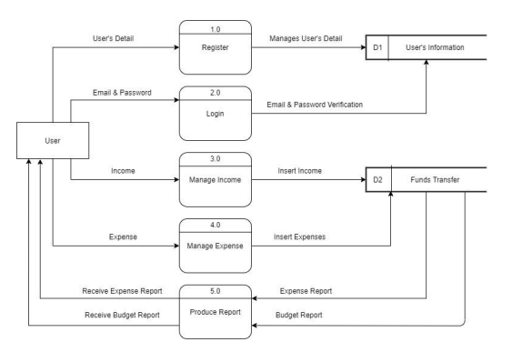
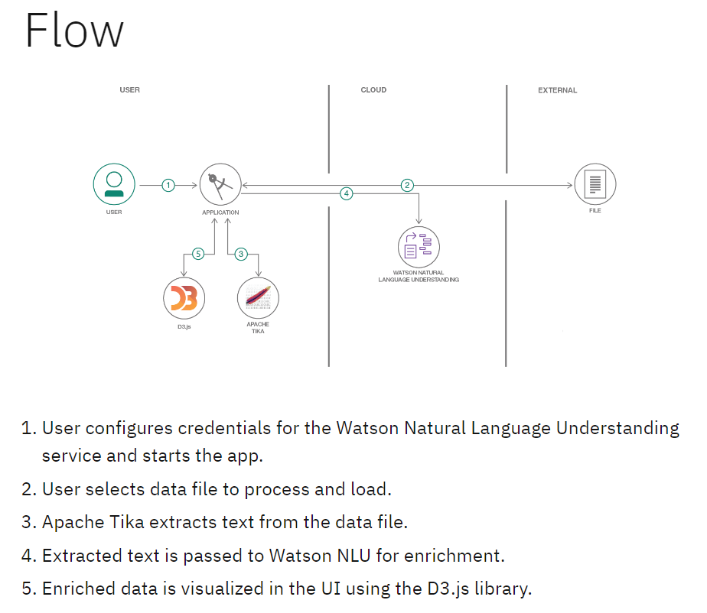

User Stories
Use the below template to list all the user stories for the product.
User Type | Functional Requirement (Epic) | User Story Number | User Story / Task | Acceptance criteria | Priority | Release
Customer (Mobile user) | Registration | USN-1 | As a user, I can register for the application by entering my email, password, and confirming my password. | I can access my account / dashboard | High | Sprint-1
 | Login | USN-2 | As a user, I can log into the application by entering email & password | I can log in and access my account | High | Sprint-1
 | Income | USN-3 | As a user, I can manage income by entering income details | I can manage income and fund transfers | High | Sprint-2
 | Expense | USN-4 | As a user, I can manage expense by entering  expense details | I can manage expense and fund transfer | Medium | Sprint-1
 | Report | USN-5 | As a user, I can manage the expense and budget | I can receive expense report and budget report | High | Sprint-1
Customer (Web user)
Customer Care Executive
Administrator

